Tracing A Recursion

When we See Loops and Recursion both are kind of similar but the Big Difference is Loop Is Travel One direction but Recursion travels both directions

* Loop Direction
* Recursive Direction

That Both Directions are :

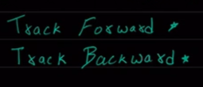

Code Example 1 :

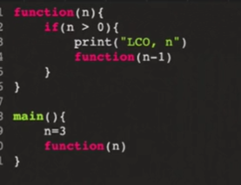

Now we draw the tree diagram

When we draw a diagram first it check the condition if the condition true it print the statement and call the same function with -1 this is Trace Forward

Diagram :

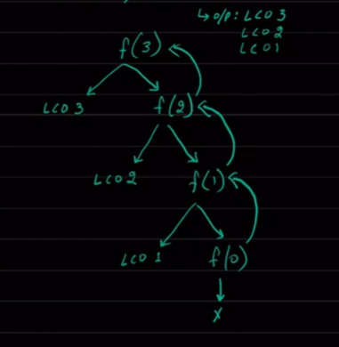

So It print from 3 , 2 , 1 , we print everything in Forward call

This is Trace Forward

Output :

LCO 3

LCO 2

LCO 1

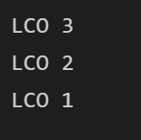

Code 2 :

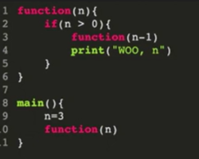

Output :

Woo 1

Woo 2

Woo 3

Here it is Trace Backward , we print Everything Backward call

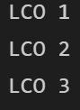

First it call the function until f(0) then backward it print One by one

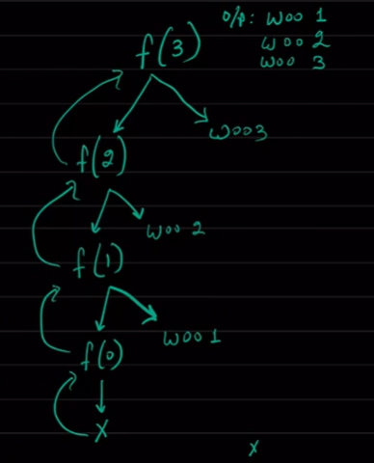

Types Of Recursion

* Head / Top :

Recursion Function Execute First then the rest of the Statement Execute

Ex : Code 2

* Bottom / Last :

Recursion Function Execute Last then the rest of the Statement Execute at first

Ex : Code 1

* Tree Recursion :

Multiple Recursion Happens anywhere

Code :

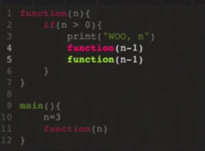

Output is :

Woo 3

Woo 2

Woo 1

Woo 1

Woo 2

Woo 1

Woo 1

So in this program every time three(3) can occurs

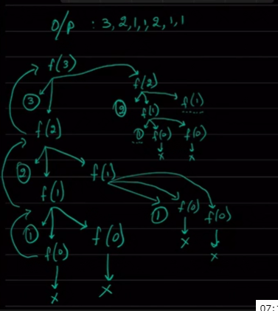

Factorial :

